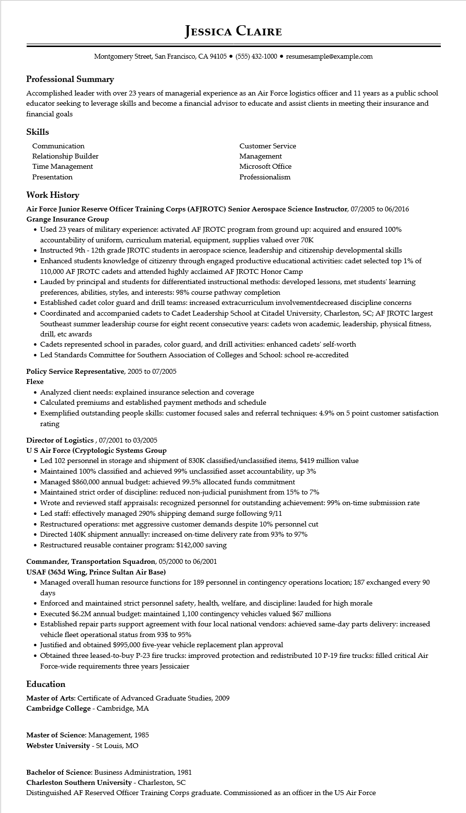
JESSICA CLAIRE
Montgomery Street, San Francisco, CA 94105 (555) 432-1000 resumesample@example.com
Professional Summary
Accomplished leader with over 23 years of managerial experience as an Air Force logistics officer and 11 years as a public school educator seeking to leverage skills and become a financial advisor to educate and assist clients in meeting their insurance and financial goals
Skills
Communication
Relationship Builder
Time Management
Presentation
Customer Service Management Microsoft Office Professionalism
Work History
Air Force Junior Reserve Officer Training Corps (AFJROTC) Senior Aerospace Science Instructor, 07/2005 to 06/2016 Grange Insurance Group
• Used 23 years of military experience: activated AF JROTC program from ground up: acquired and ensured 100% accountability of uniform, curriculum material, equipment, supplies valued over 70K
• Instructed 9th - 12th grade JROTC students in aerospace science, leadership and citizenship developmental skills
• Enhanced students knowledge of citizenry through engaged productive educational activities: cadet selected top 1% of 110,000 AF JROTC cadets and attended highly acclaimed AF JROTC Honor Camp
• Lauded by principal and students for differentiated instructional methods: developed lessons, met students' learning preferences, abilities, styles, and interests: 98% course pathway completion
• Established cadet color guard and drill teams: increased extracurriculum involvementdecreased discipline concerns
• Coordinated and accompanied cadets to Cadet Leadership School at Citadel University, Charleston, SC; AF JROTC largest Southeast summer leadership course for eight recent consecutive years: cadets won academic, leadership, physical fitness, drill, etc awards
• Cadets represented school in parades, color guard, and drill activities: enhanced cadets' self-worth
• Led Standards Committee for Southern Association of Colleges and School: school re-accredited
Policy Service Representative, 2005 to 07/2005
Flexe
• Analyzed client needs: explained insurance selection and coverage
• Calculated premiums and established payment methods and schedule
• Exemplified outstanding people skills: customer focused sales and referral techniques: 4.9% on 5 point customer satisfaction rating
Director of Logistics, 07/2001 to 03/2005
US Air Force (Cryptologic Systems Group
• Led 102 personnel in storage and shipment of 830K classified/unclassified items, $419 million value
• Maintained 100% classified and achieved 99% unclassified asset accountability, up 3%
• Managed $860,000 annual budget: achieved 99.5% allocated funds commitment
• Maintained strict order of discipline: reduced non-judicial punishment from 15% to 7%
• Wrote and reviewed staff appraisals: recognized personnel for outstanding achievement: 99% on-time submission rate
• Led staff: effectively managed 290% shipping demand surge following 9/11
• Restructured operations: met aggressive customer demands despite 10% personnel cut
• Directed 140K shipment annually: increased on-time delivery rate from 93% to 97%
• Restructured reusable container program: $142,000 saving
Commander, Transportation Squadron, 05/2000 to 06/2001
USAF (363d Wing, Prince Sultan Air Base)
• Managed overall human resource functions for 189 personnel in contingency operations location; 187 exchanged every 90 days
• Enforced and maintained strict personnel safety, health, welfare, and discipline: lauded for high morale
• Executed $6.2M annual budget: maintained 1,100 contingency vehicles valued $67 millions
• Established repair parts support agreement with four local national vendors: achieved same-day parts delivery: increased vehicle fleet operational status from 93$ to 95%
• Justified and obtained $995,000 five-year vehicle replacement plan approval
• Obtained three leased-to-buy P-23 fire trucks: improved protection and redistributed 10 P-19 fire trucks: filled critical Air Force-wide requirements three years Jessicaier
Education
Master of Arts: Certificate of Advanced Graduate Studies, 2009
Cambridge College - Cambridge, MA
Master of Science: Management, 1985
Webster University - St Louis, MO
Bachelor of Science: Business Administration, 1981
Charleston Southern University - Charleston, SC
Distinguished AF Reserved Officer Training Corps graduate. Commissioned as an officer in the US Air Force

